All of these plots were made with Audio tester V2.2 running on an old Athalon 600. The soundcard is only good to 48KHz, and rolls off to -1dB around 35KHz, so take this into account and compare the red trace (direct feedback plot of audio card) to the blue trace which is the amp with the transformer being tested.

The amp is the Sven 6P1P PP prototype running 256V anode to cathode, 250V screen, cathode bias around 44mA, direct coupled first stage (6N1P-EV) to Cathodyne splitter (6N23P-EV) with unmatched 6P1P-EVs in the output stage. Cathodyne to grid of 6P1P is 0.022uF with 680K grid to gnd, no grid stopper resistors.

My interpretation is that the Meng Yue Mini transformers are pretty good as far as frequency response goes. They do seem to exhibit slightly sharper peak around 32KHz compared to the 28KHz peak with the Hammond 1608 transformer.

Interestingly enough, the Hammond 1609 does not show this peak (unless it is the discontinuity at 40KHz), nor does the Olson (Made in Japan in the early 70s?). These transformers may show a peak at a higher frequency that is just not detected with my test setup.

The Meng Yue Mini transformer shows increasing amplitude with frequency, although it is pretty flat with around 1dB increase from 100Hz to 10KHz.

Lower end frequency response of the Meng Yue rolls off -3dB around 30Hz compared to -3dB at 20Hz for the Hammond and -3dB at 25Hz for the Olson transformer. This correlates to the lower primary inductance (5.4H) of the Meng Yue compared to the Hammond at 12.3H and Olson at 7.4H.

The Meng Yue Mini also shows slightly less output (1/2 – 1dB) than the Hammond transformers, which are also about 2dB lower than the Olson transformer.

How much variation does one see from unit to unit with the same manufacturer?

The Meng Yue Mini transformer in my opinion is a good transformer with the exception of the construction issues pointed out earlier in the Meng Yue thread(s) on the DIY forum.

With minimal global NFB all of these transformers should perform quite well.

An example of the effect of GNFB can be seen in the last plot of the Olson compared to it’s previous plot. Here approximately 8dB of GNFB has been added from output transformer speaker tap to the cathode resistor of the first stage (Current mode feedback). This has pushed the -3dB lower end down from 25Hz to around 11Hz. -1dB band pass is roughly 20Hz to 40KHz compared to 60Hz to 20KHz without GNFB.

SPP 3-18-2010

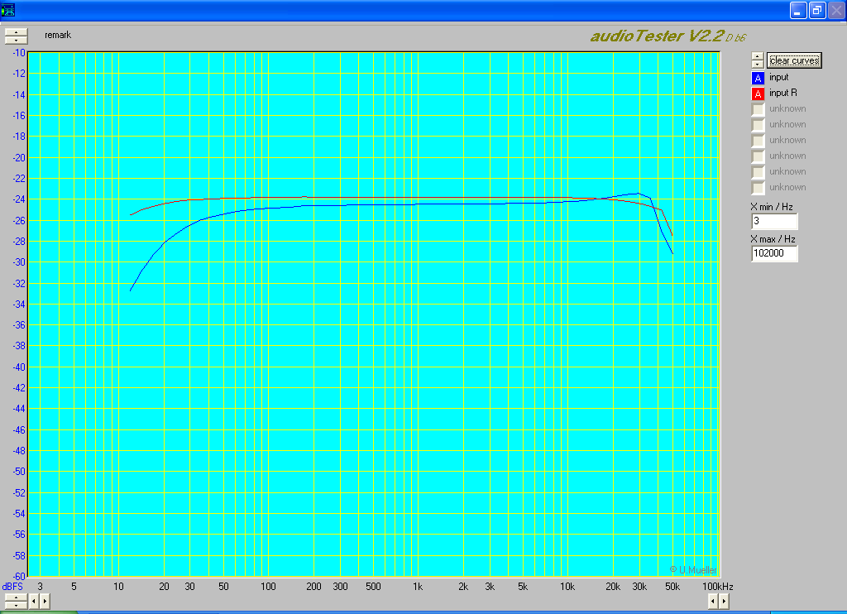
Hammond 1608
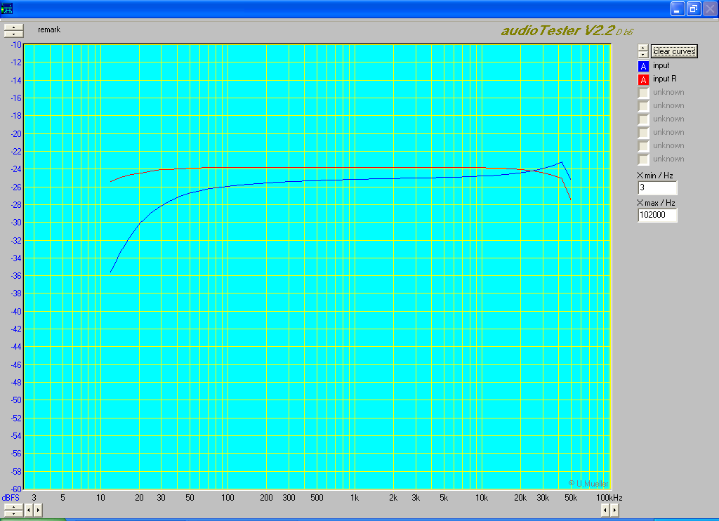
Meng Yeu Mini
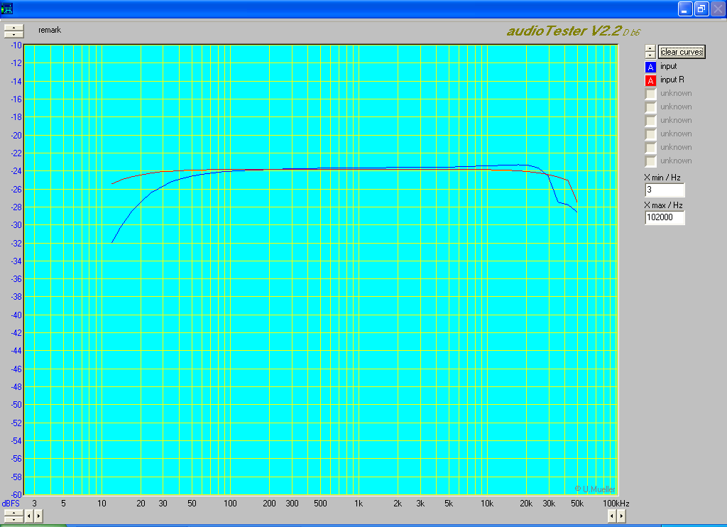
Hammond 1609
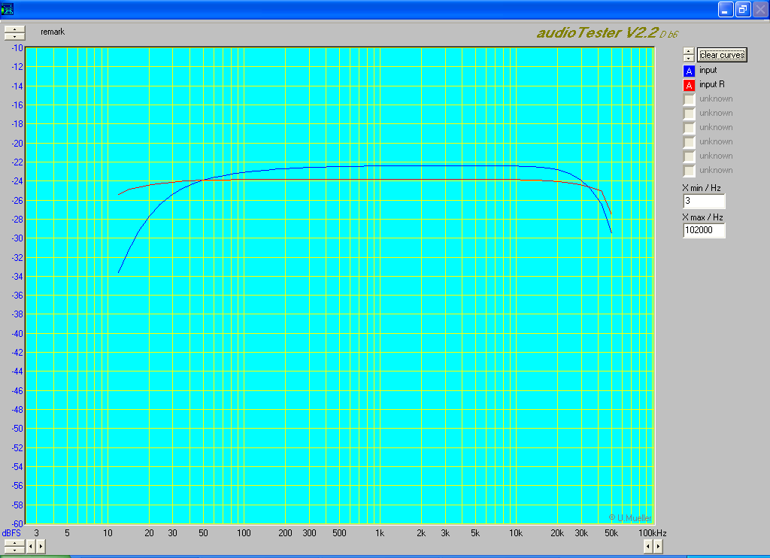
Olson
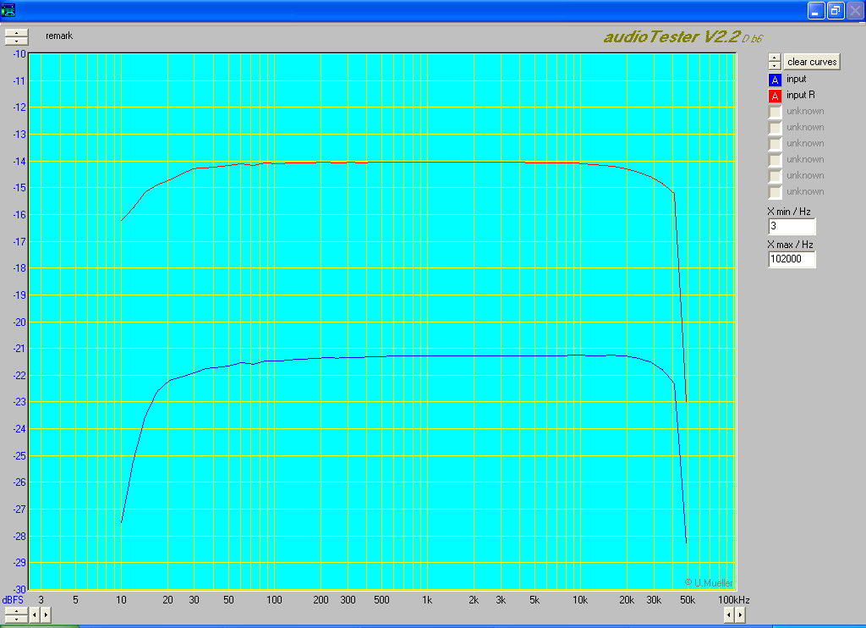
This last plot is the Olson transformer with 8dB (?) GNFB added to see how it would flatten the curve. It worked quite well. -3db on the low end is now down near 11Hz, and the curve is flat out to 48KHz which is as good as the test set can measure!

